SEMESTER | : | OCT 2025 – MAC 2026
COURSE | : | Image processing
COURSE CODE | : | CSC566
PROJECT TITLE | :

Group Name: | ONE
Name, Student ID: | 1.
 | 2.
 | 3.
 | 4.
Group:
Lecturer Name: | Ts. ZAABA BIN AHMAD

TEMPLATE FOR PROJECT GRADING

Each group should complete and print this sheet. Bring along during the presentation, together with the report and code.

ITEMS | FULL MARKS | MARKS
PRESENTATION:  - System Prototype in GUI  - Overall project presentation  - Delivery skills | 5%
REPORT:  - Introduction  - Objectives  - Data collection  - Flowchart  - Results of Prototype  - System Prototype in GUI  - Sample Input Output  - Source Code  - Conclusion | 15%
PAPER:  Abstract  1. Introduction  2. Methodology  2.1 Dataset  2.2 Proposed System Involved  3. Results dan Discussion  4. Conclusion  References | 10%
TOTAL MARKS | 30%

MINI PROJECT (30%)

Instructions

- Use the project cover sheet as provided (pages 1 and 2).
- This is a group project. Each group consists of 3-4 members.
- Please hand over the hard copy of the report to Ts. Zaaba Ahmad
- General format:
  - Font: Arial (for report) and Courier New (for source code)
  - Font size: 12
  - Table: Arial, 9
  - Spacing: 1.15 (for report) and 1.0 (source code)

- Special remarks:
  - No marks will be given for late submission.
  - Any copied project (with NO EXCEPTION) will be given 0 (zero) mark.

- Your project will be marked based on the requirements on the cover sheet.
- Presentation, report and paper submission are on the first class of week 14.

Topic and Dataset Selection Guidelines
You must select a topic and dataset that allows you to explore and apply image processing techniques effectively. The project will focus primarily on image processing methods, which may serve as a pre-processing step before applying advanced deep learning models. The goal is to innovate or enhance existing methods to improve overall model performance in a computer vision task.

Dataset Selection
Source: All datasets must be sourced from Kaggle (kaggle.com), which provides a wide range of image datasets suitable for various computer vision tasks.
Criteria: Choose a dataset that:
- Contains image data that can be processed and analysed using image processing techniques.
- Is relevant to a real-world application and poses a challenge that can benefit from both conventional image processing and potential deep learning approaches.
- Has sufficient documentation and metadata to understand the context and details of the images and tasks involved.

Topic Selection
Focus Area: Select a topic within the realm of image processing that interests you and can benefit from innovative processing techniques. Example areas include, but are not limited to:
- Medical imaging (e.g., tumour detection, organ segmentation)
- Environmental monitoring (e.g., land use, deforestation detection)
- Public safety (e.g., surveillance, crowd analysis)
- Agriculture (e.g., plant disease identification, yield estimation)
- Retail and fashion (e.g., product recognition, virtual try-on)
Innovation in Image Processing: Your project should aim to enhance or innovate in the following aspects:
- Pre-processing techniques for improving image quality or feature extraction, such as noise reduction, contrast enhancement, or morphological operations.
- Image segmentation and object detection improvements.
- Feature enhancement for better classification or recognition in subsequent deep learning stages.
Deep Learning Integration (Optional):
While the focus should be on image processing techniques, you may integrate deep learning models like Convolutional Neural Networks (CNNs) to demonstrate how pre-processing improves model performance.
If you integrate deep learning, ensure that the emphasis remains on the novel use of image processing techniques. Deep learning should complement, not overshadow, the image processing work.

Guidance and Support
Self-Learning: Students are encouraged to self-learn, especially for deep learning aspects. Explore online resources, academic papers, and tutorials on Kaggle, Coursera, and YouTube.
Lecturer Consultations: If you choose to incorporate deep learning into your project and require guidance, please book an appointment with the lecturer. Prepare specific questions or topics for discussion to make the most of your consultation.
Submission Requirements
Proposal: Submit a project proposal that includes your chosen dataset, a detailed description of your selected topic, and an outline of the image processing techniques you plan to develop or improve. Due – Week 12.
Final Report: Your final submission should include a comprehensive report detailing your methodology, experiments, results, and a discussion of how the image processing techniques impacted the overall task.
PRESENTATION (5%)

Marks will be given based on the following criteria:

- System Prototype in GUI
- Overall project presentation
- Delivery skills

REPORT (15%)

Specification

For this mini project, you are required to experiment and write a program on the given topics using Matlab software. Your project report should follow the requirements based on the given format. Please include a report based on the format below:

- Project report cover (use given page 1 – 2 as provided)
- Table of content
- Introduction to the project
- Objectives of the project
- Data collection (specify the total images that have been used and location or areas covered for experimental data)
- Flowchart of selected methods (based on your source code and technique). Use and experiment the same flowchart and methods for all images.

- Results

Submitted report must be included all the processes (original image, process 1 etc) involved. MATLAB scripts should work for all image datasets. All results must construct in the table. Sample of the results are shown as Table below. The content of Table can be constructed based on your flowchart.

Table 1: Sample of Image Segmentation Results
No. | Original Image | Sobel Edge Detection | Dilated Gradient Mask | Filled In Holes And Cleared Border Image | Erosion Gradient Mask And Remove Small Region | Segmented Image
1. | 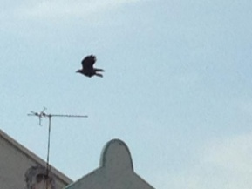 |  | 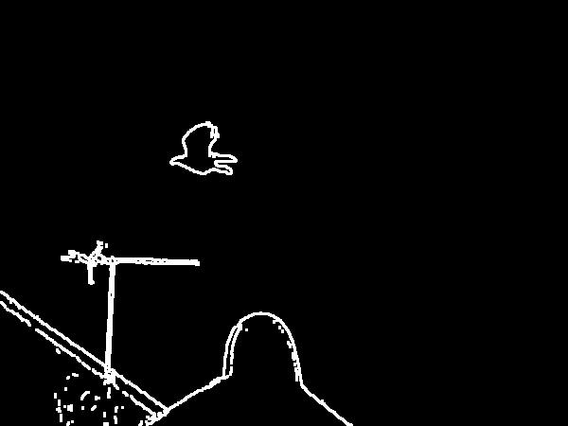 |  |  | 
2.

Table 2: Sample of Texture Feature Extraction Results

No. | Original Image | Binarization | Segmented Image | Grayscale Image | Region of Interest | Results of Mean, Standard Deviation and Smoothness
1. | 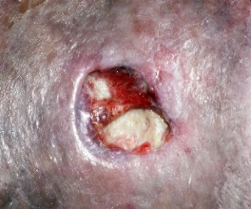 |  | 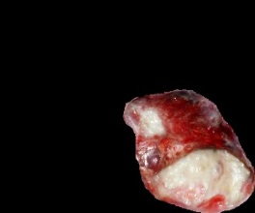 | 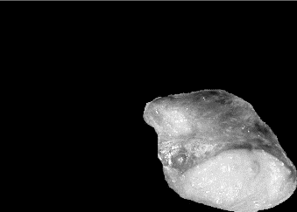 |  | Mean: 0.0156  Standard Deviation: 0.1142  Smoothness: 0.0129
2.

- System Prototype in GUI
- Sample input and output of GUI (screenshots)
- Source code with proper comments
- Conclusion
- References
- CD (please include your source code and report)

Note: Please use the same method (source code) for all image dataset.

For segmentation stage, you may use the following segmentation technique below and apply to all the datasets.

- Clustering methods
  - Center-based clustering (ie. K-means, x-means etc)
  - Fuzzy clustering (ie. K-means, C-means etc)
- Edge based methods
- Region based methods
  - Region growing algorithm
  - Watershed
  - Split and merge algorithm
  - Mathematical morphology
- Threshold method (It is simple method. Please add another method when you applied the thresholding method.)
  - Global thresholding (Otsu method)
  - Adaptive thresholding
  - Double thresholding
- Template based methods
- Partial differential equation-based methods
  - Parametric methods
  - Level set methods
  - Fast marching methods
- Skeleton algorithm
- Histogram-based methods
  - Color segmentation
  - Intensity
- Active contour or snake algorithm
- Level set model
- C-V model
- Graph partitioning methods
  - Markov Random Fields
- Hybrid methods
- Segmentation based on Artificial Neural Network
- Any other methods

Your documentation should contain original image and process image.

PAPER (10%)

- Follow the format based on the given guidelines and instructions in class.
- Please explain and discuss all the processes involved.

